Important:
Please send us the proposal first electronically as *.docx.
After we mutually agree, please sign the proposal and send the scan via e-mail.

We only measure samples after mutual agreement of feasibility and scientific reason.

Project Title (please give a brief, yet informative title)

Acronym (starts with O-) |  | Start date
O-

Principle Investigator PROVIDER (of material to be analyzed) -

(Institute, address, email, telephone)

Involved people/institutes/planned authorships (according to Regulations for Good Scientific Practice, https://wissenschaftliche-integritaet.de/kodex/autorschaft/)

HMGU PSP-Element and POF topic (only internal)

Billing Address and VAT-ID (only external)

Project summary: a short description of the project, including aims and benefits

Study design:
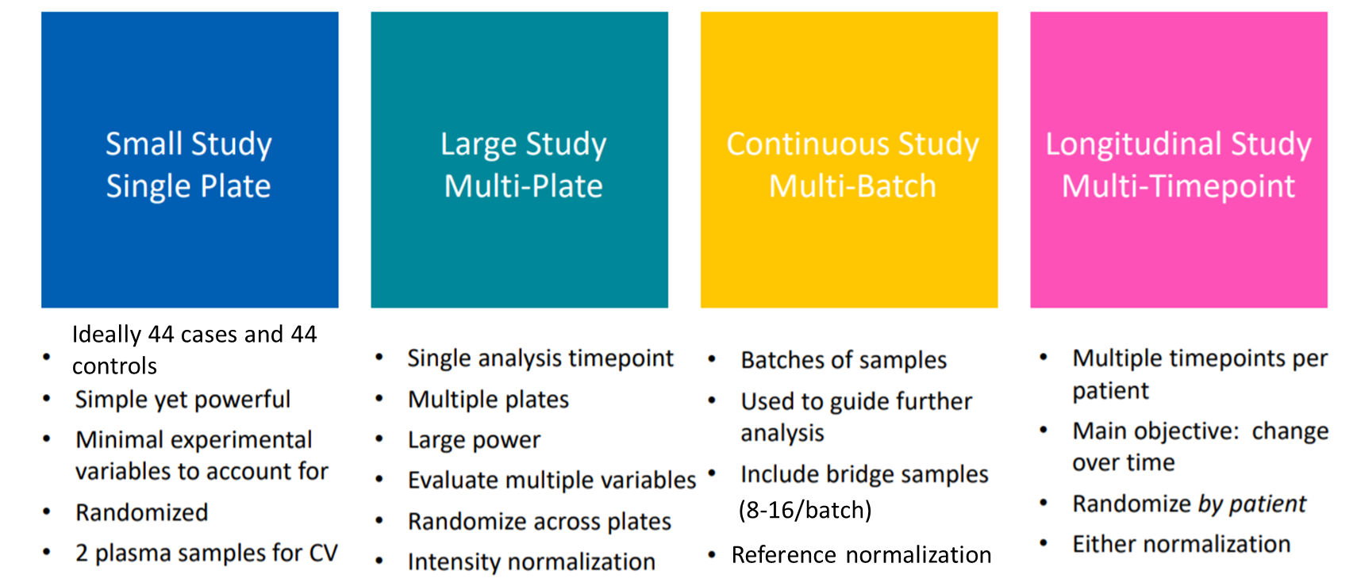

• Which study design scenario better suits your project:

• What is the study objective:

• What are the study groups and how many samples are in each group:

• What is the sample type (EDTA plasma, heparin plasma, serum, cell, or tissue lysate. Note: different sample matrices cannot be compared!):

• What are the pre-analytical variations (specify which variables are present in your samples such as gender, age, collection site, collection tube, state of disease, sample matrix, longitudinal time points, sample storage time, and freeze-thaws):

Selected Olink Panel/s | Number of samples | Number of plates

Risk assessment of samples: Have samples been tested for HIV, HBV, HCV, or other blood-borne diseases?
- Yes If ‘Yes’, please state if positive or negative
- No Comment:

Human biospecimens ethical consent
Ethical approval number (if applicable):
Approving institutional review board or equivalent committee(s):

Plate Layout & Randomization of samples
- Randomized in plates (ready to use)
- Randomized in tubes (ready to transfer to plates)
- Other (please specify):

After measurements samples should be  [check field] | ☐ retrieved by the provider at own costs (Please place an order with a courier company to pick samples up at our facility)  ☐ destroyed after 6 months of storage at -80 °C

Declaration of consent
I consent to the information and contact details provided by myself being used by Helmholtz Zentrum München to contact me for communication purposes and address my query. This is especially applicable for the use of my E-Mail address and potentially my phone number. I know that I can revoke my consent to the collection, use, and storage of my personal data at any time by sending my revocation to proteomics@helmholtz-munich.de. For any queries regarding the use of my personal data on this website, please see the DATA PROTECTION STATEMENT (https://www.helmholtz-muenchen.de/en/privacy-statement/index.html) For any further inquiries regarding your personal data, please contact our Data Protection Officer at: datenschutz@helmholtz-munich.de

Click here to agree*
☐ I have read the Data protection statement and I agree.
☐ I have read the notes above and I agree.

____________________ _______________________________
Place, Date Signature

Please read carefully below before you proceed with shipping:

- STUDY DESIGN:

- SAMPLE SELECTION:
Careful sample selection can help alleviate bias in results.
- Cases and controls must be the same sample matrix (different plasma collection methods are different matrices!).
- Control samples should be well matched to cases (ethnicity, age, sex differences can introduce bias).
- Sample handling variability should be kept at a minimum between all samples in a study.
- Use a balanced design (same number of samples in each group) as far as possible. If the size of the groups is not the same, power is best increased by enlarging the smallest group.

- SAMPLE RANDOMIZATION:
Correct sample randomization will empower your study and minimize the risk of introducing any bias that can confound downstream analyses. If randomization is not performed, the normalization might remove true biological variation that otherwise could have been identified.
Therefore ensure that your samples are optimally randomized so that all variables present in your cohort are balanced across and within plates. Variables to randomize for include study groups, treatment, sampling time points or demographics, plasma collection procedure, sample matrix (EDTA, heparin, citrate…). Samples in a longitudinal study that are collected from the same individual at different time points should all be included on the same plate to further reduce variation in the data.

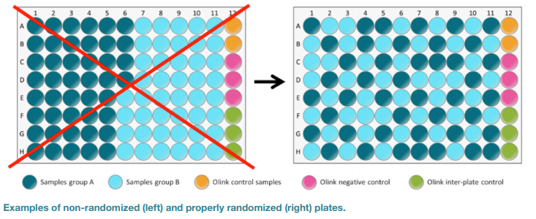

- BRIDGING SAMPLES – COMPARE SAMPLES FROM DIFFERENT RUNS:
If you want to compare results from two or more studies conducted in different time frames, or when samples cannot be randomized across multiple plates in a single study, Olink recommends including 8-16 bridging samples in each study. For non-randomized studies, bridging samples should be included on each plate. The bridging samples should be representative of the entire study, for example, include all study groups and be matrix-matched with the other samples. These samples will help reduce technical variation between runs and/or plates.

- SAMPLE PREPARATION:

- One kit measures 88 samples in a 96-well plate format.
- Sample volume:
TARGET 96: provide 10 µl of each sample to screen up to 3 panels. Provide 20 µl of sample to screen 4-8 panels.
EXPLORE 834/1536: provide 30 µl of each sample.
EXPLORE 3072: provide 60 ul of each sample.
- Sample plate: deliver your samples in a 96-well PCR plate full skirt Sarstedt #72.1980.202 with a seal from Life Technologies #4306311 or the biobanking system from Matrix, Thermo Fisher. Other suppliers have not been tested by Olink, therefore we strictly recommend using the above-mentioned products.
- For cell or tissue lysate preparation protocols, we provide guidelines and optimized protocols. Ensure always equal total protein concentration in all samples.
- Ensure that each well is properly sealed using the adhesive film (the adhesive film suggested above is suitable also for long-term storage of samples at -80°C).
- Clearly mark sample plates (best is with a barcode) or tubes with your name and number of plate/tube (eg. Smith_Plate1) using temperature-resistant labels or marker pen.

Plate layout:
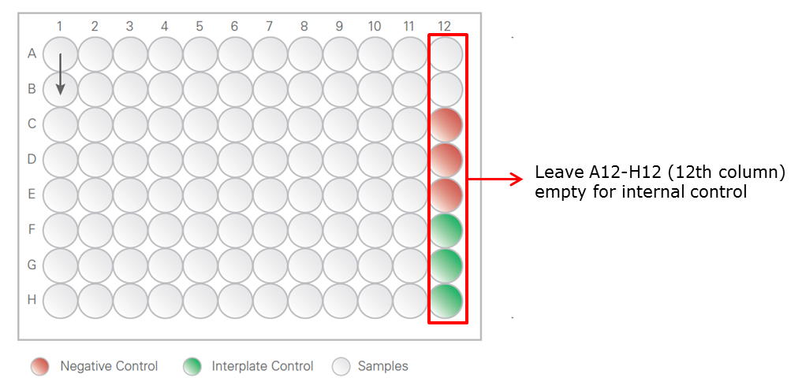

- SHIPPING:
- Ship samples in -80°C/dry-ice-resistant, non-protein binding plastics.
- Make sure that the plates are securely sealed, add extra adsorption paper in case of leakage, and place the samples in a sealed bag.
- Samples should be shipped on dry ice, sufficient for delivery to our Analysis Service lab.
- For most customers it is recommended to ship the samples on Monday or Tuesday to avoid getting the samples held up at the courier’s office over the weekend. Upon arrival, the samples will be examined, and you will receive a confirmation email. Samples will be stored at -80°C at our facility.
NOTE: The Project Proposal and the Sample Submission Sheet should be filled in and emailed back to us before you ship the samples.

- RESULTS:
The results will usually be sent to you within 2-4 weeks after we received the samples. Once the samples have been analyzed and the data has gone through our Quality Control, you will receive the data presented in Normalized Protein eXpression (NPX) units in an Excel file, as well as a Certificate of Analysis (summary report). Olink results are presented as relative quantification data and NPX is Olink’s arbitrary unit on a log2-scale. You can read more about NPX and data generation here:
https://www.olink.com/data-you-can-trust/data-generation-qc/

- MORE INFO ON DIFFERENT TOPICS:
Below you will find links to the resources referred to in this document, as well as other direct links to pages containing important information relating to Olink data generation and processing.
- OLINK WHITE PAPERS: https://www.olink.com/white-papers
Pre-analytical variation in protein biomarker research
Technical comparisons and orthogonal validation Olink vs. ELISA
Strategies for the design of protein biomarker studies
Data normalization and standardization
Development and validation of customized PEA biomarker panels with clinical utility
PEA – a high-multiplex immunoassay technology with qPCR or NGS readout

- Sample randomization:
https://www.olink.com/question/sample-randomization
- Data normalization:
https://www.olink.com/question/data-normalization
- Bridge sample normalization:
https://www.olink.com/question/how-can-i-compare-results-from-two-different-studies/
- How is the quality control performed?
https://www.olink.com/question/how-is-quality-control-of-the-data-performed
- The NPX unit explained:
https://www.olink.com/question/what-is-npx
- Generation of NPX data:
https://www.olink.com/question/how-is-the-data-pre-processed
- Limit of detection:
https://www.olink.com/question/how-is-the-limit-of-detection-lod-estimated-and-handled

