Guidelines for the use of the proteomics platform of CF-MPC
The Core Facility Metabolomics and Proteomics (CF-MPC) offers high-quality, state-of-the-art services individualized to your project needs. All available proteomics assays including O-LINK are provided by core facility personnel only, a self-service option is not available.
It is mandatory to contact us before the start of a project to arrange for an in-depth consultation session (CF-MPC-PROT@helmholtz-muenchen.de). In our experience users achieve the best results when involving us at the earliest stages of a project, but in any case before starting with sample preparation. Proteomics experiments must be carefully designed and have special requirements in terms of sample preparation, data generation, and statistical validity.
We accept a broad range of human and non-human sample types such as plasma, serum, stool, tissue culture supernatant. All tissue material delivered to CF-MPC must be of Biosafety grade 2 (BSL-2). If you are working with samples above BSL-2 you must contact the head of CF-MPC (hauck@helmholtz-munich.de) to discuss if they can potentially be measured after thorough fixation and obtain prior written permission before sending such specimens by the head of CF-MPC (hauck@helmholtz-munich.de). All sample material must arrive at the core in a fully anonymized manner. The core facility will store sample material only for the duration of the project. Any leftover material will be discarded or shipped back at the users’ expense upon request.
Users are responsible for ensuring that any scientific experiment carried out at CF-MPC fulfills the relevant ethical and legal specifications.
Furthermore, every user is responsible to provide a valid source of payment for the work ordered and as outlined in the quote provided by CF-MPC. This has to be confirmed in writing on the project proposal form by the head of the research team.
Data are stored for a maximum of 10 years in our LIMS system. We typically provide our users with processed, results-focused data reports. While internal customers can download all raw data via the LIMS system, external clients will agree on a data delivery path during the initial project discussion.
Please follow the procedure outlined below to guarantee the efficient completion of your project.
- Initial project meeting at an early stage:
Please arrange for a mandatory project discussion of your proteomics experiment (CF-MPC-PROT@helmholtz-munich.de). Sample preparation, suitable protocols, project planning, and more details will be discussed in the meeting. Please also consider the downstream data analysis path, we are experts at qualitative and quantitative analysis and data interpretation of proteomics data sets.

- Project proposal form:
A further prerequisite is the submission of a project proposal. Please include any information needed to provide a clear and solid understanding of your goals and expectations.
Please download the Project Proposal Template for Proteomics and complete all requested information. This project proposal will contain the results of the discussions from the previous meeting (step 1) and needs to be sent in Word file format (.docx) to the scientist in charge of your project who will add the prospective effort for the facility and provide a quote and time estimate for your work. After mutual agreement, please sign the document and send it as .pdf. Work will commence only after receiving the signed project proposal with a valid funding source.

- Request User ID:
To submit samples to our LIMS system, first-time users need to request a User ID (LabLink). You should then receive an automated e-mail with your Username and Password within one day.

- Sample preparation:
The success of any proteomic experiment depends largely on sample preparation protocols compatible with mass spectrometry. Therefore, we use standardized SOPs (see below) that are well tested and mandatory to use for the processing of samples by the Proteomics platform. Please carefully read and follow the instructions in these SOPs. If you have any questions please do not hesitate to contact us (CF-MPC-PROT@helmholtz-muncih.de).
Staining (Coomassie Staining, Silver Staining)
Precipitation (Methanol-Chloroform-Precipitation)
Digestion (In-Gel Digest, In-Solution Digest)

- Sample submission:
Please download the sample submission sheet directly from LabLink. It is important to download a new sheet for each submission. HMGU data safety rules require users to save this file locally on their computer BEFORE they start filling in the requested information.
Users must complete a new sample submission sheet for each new submission which will generate a unique identifier for each sample. Also, it is relevant to think about the order of your samples before you submit them. We strongly encourage you to get advice on these aspects from the scientist in charge of your project at the Core Facility.
Please fill in as much information as possible about your samples. Yellow column headers are mandatory fields.
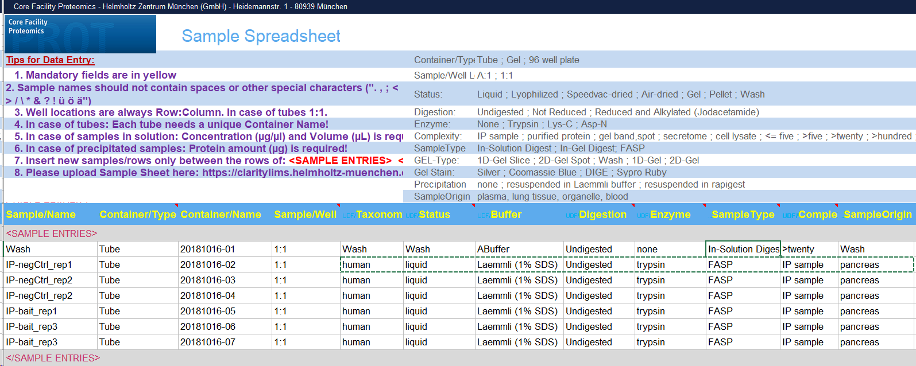
Next, please upload the excel file to LabLink. In this way, each sample will obtain its unique LIMS-ID which you have to use for labeling your samples tubes. Please print a screenshot of the LIMS-IDs for your samples in LabLink (browse to “open projects”) see picture below. We need a copy of this print-out alongside your samples upon delivery to the core.
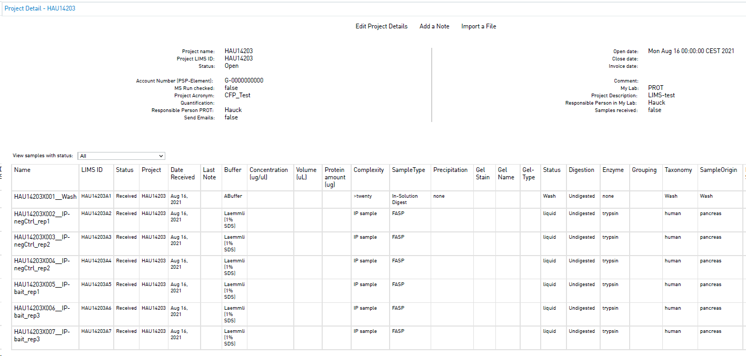
As the core facility processes large numbers of samples from multiple projects we need our users to label all tubes according to our guidelines. Before bringing or shipping samples to use please follow the instructions in the graphic below.
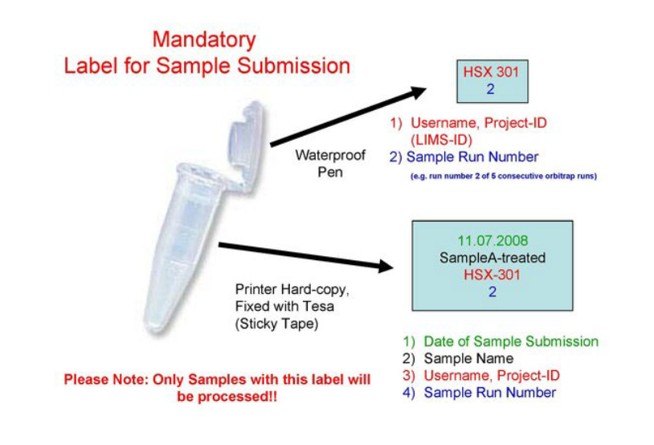
- Samples are to be stored on dry ice and can be delivered in person or shipped using a commercial service at the user’s expense. Please always contact us before bringing or shipping samples via email CF-MPC-PROT@helmholtz-munich.de For sample safety avoid shipment over the weekend and close to bank holidays.
Delivery address:
Helmholtz Zentrum München
Core Facility MPC – Proteomics Platform
Attn: Dr. Juliane Merl-Pham/Dr. Christine von Törne
Heidemannstrasse 1, 1. OG
80939 Munich, Germany

